[UXR Report] Customer Perceptions of UI Attractiveness on TV Experiences
DDG Research Team: Brandon Fluegel Jen-Tse [C] Dong Tom Lorusso Michael Bohan
_____________________________________________________________________________________________________________________________________

Executive Summary
While visually pleasing aesthetics on TV-based experiences are known to impact customer sentiment; visual design can also impact customer mental demand and performance when searching for and discovering content. This present study investigated the relationship between customer perceptions of UI aesthetics, perceived mental demand, and various UI attributes such as perceived attractiveness, visual complexity and visual density (‘clutter’).
To capture objective measures of emotional activation and information processing demands when viewing a variety of TV-based experiences, this research had customers wear brain scanning (i.e., fNIRS) and eye-tracking devices. For full method, see Appendix B. In general, while Apple TV and Netflix were found to be the most preferred UIs for visual attractiveness, their visual designs are quite different. This report describes the multifaceted relationship between UI attributes that influence visual attractiveness (e.g., content proximity, labeling, media quality) and the impact on customer mental demand and sentiment.
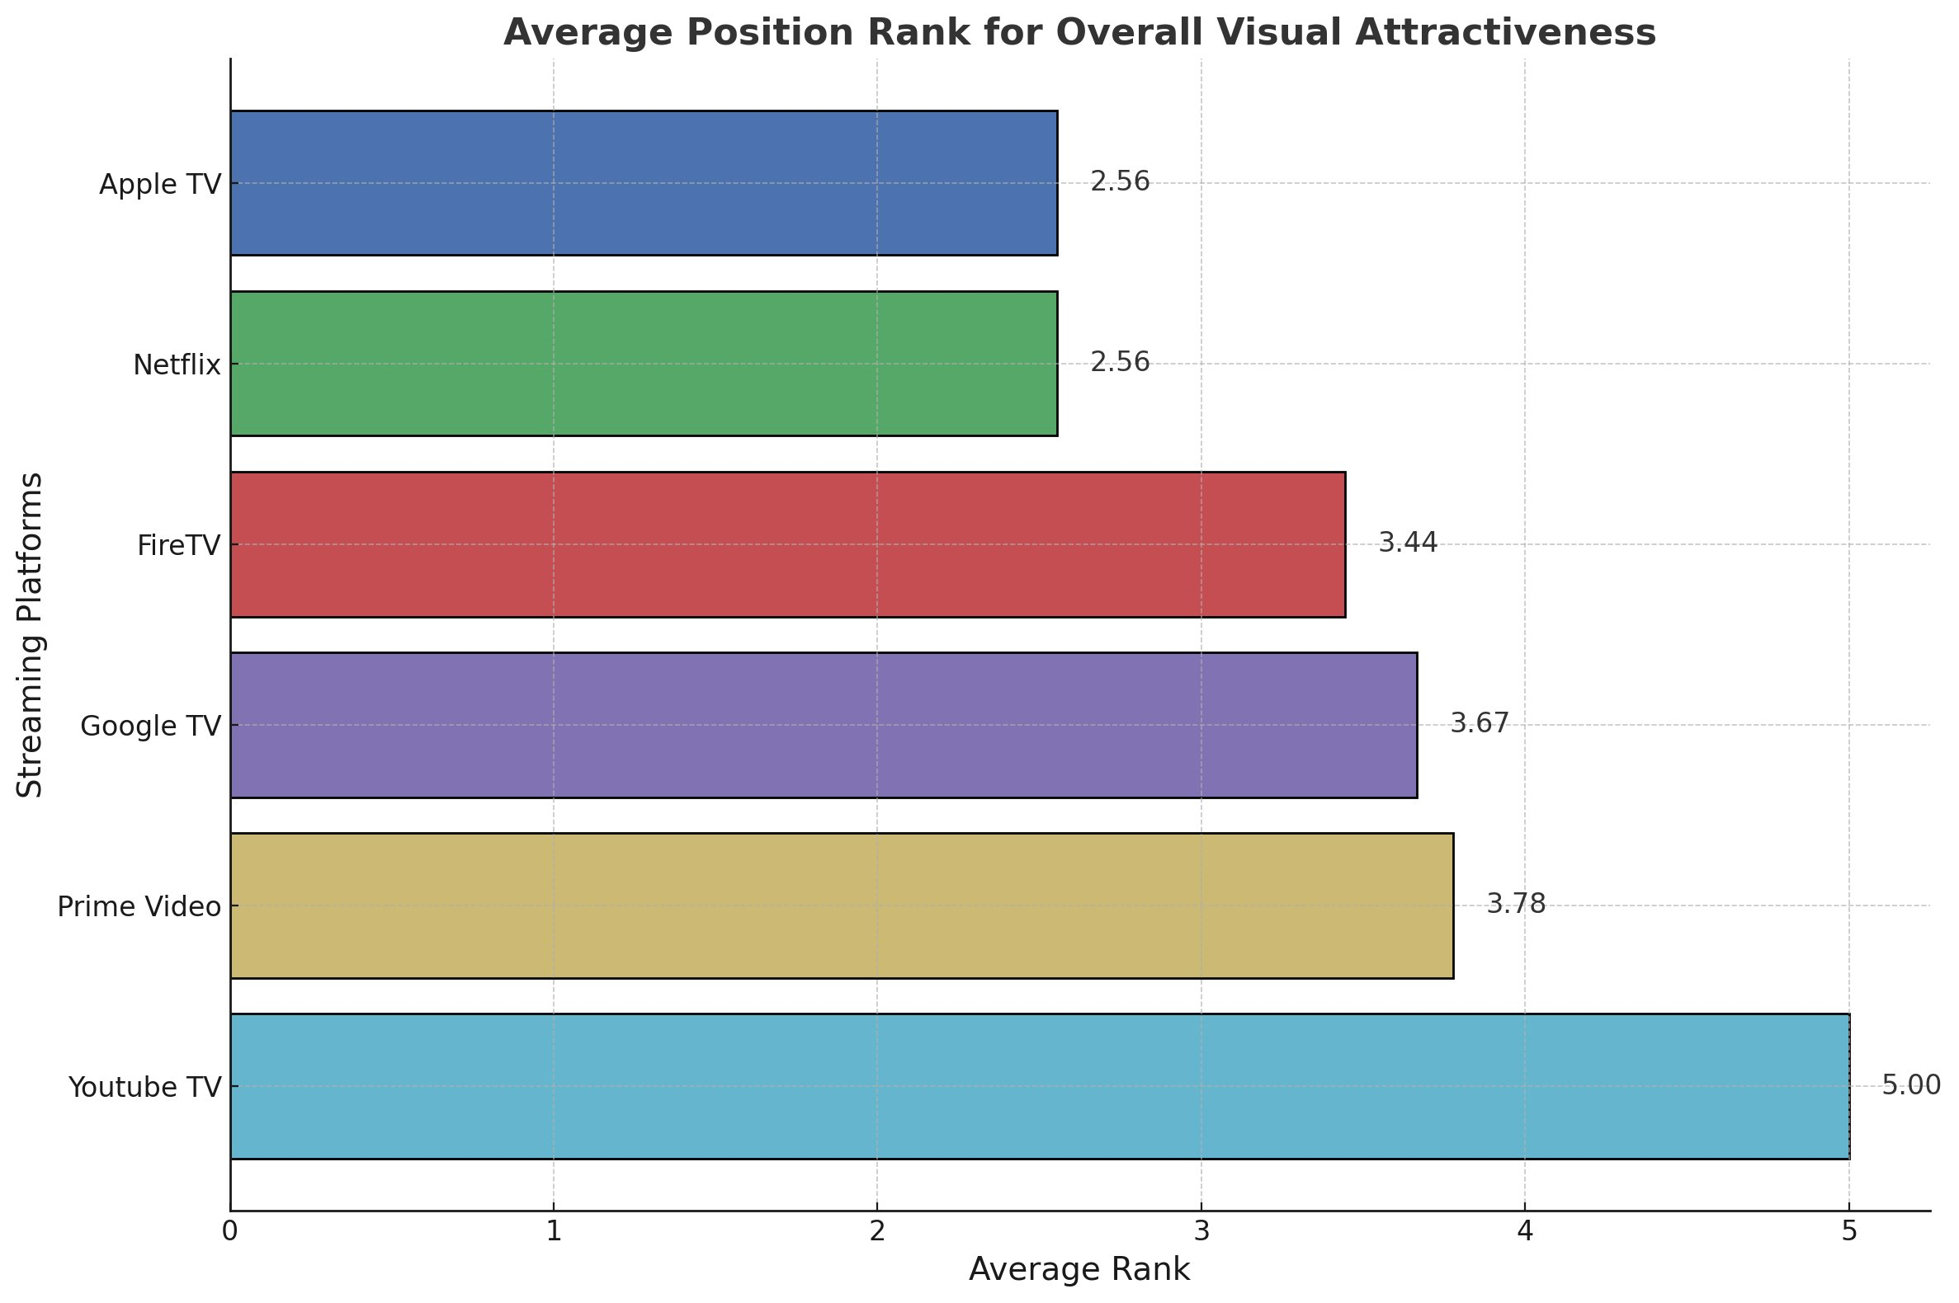
Based on initial results from pilot testing, the following hypotheses were tested:
- H1: Customers will show higher levels of mental workload in response to UIs with higher complexity
- H2: Customers will show higher levels of mental workload in response to UIs with higher density
- H3: Customers will rate Apple TV as their highest subjective preference for aesthetic appeal
- H4: Customers will rate YouTube TV as their lowest subjective preference for aesthetic appeal
- H5: Customers will rate FireTV as the UI with the highest perceived visual complexity

Study Findings
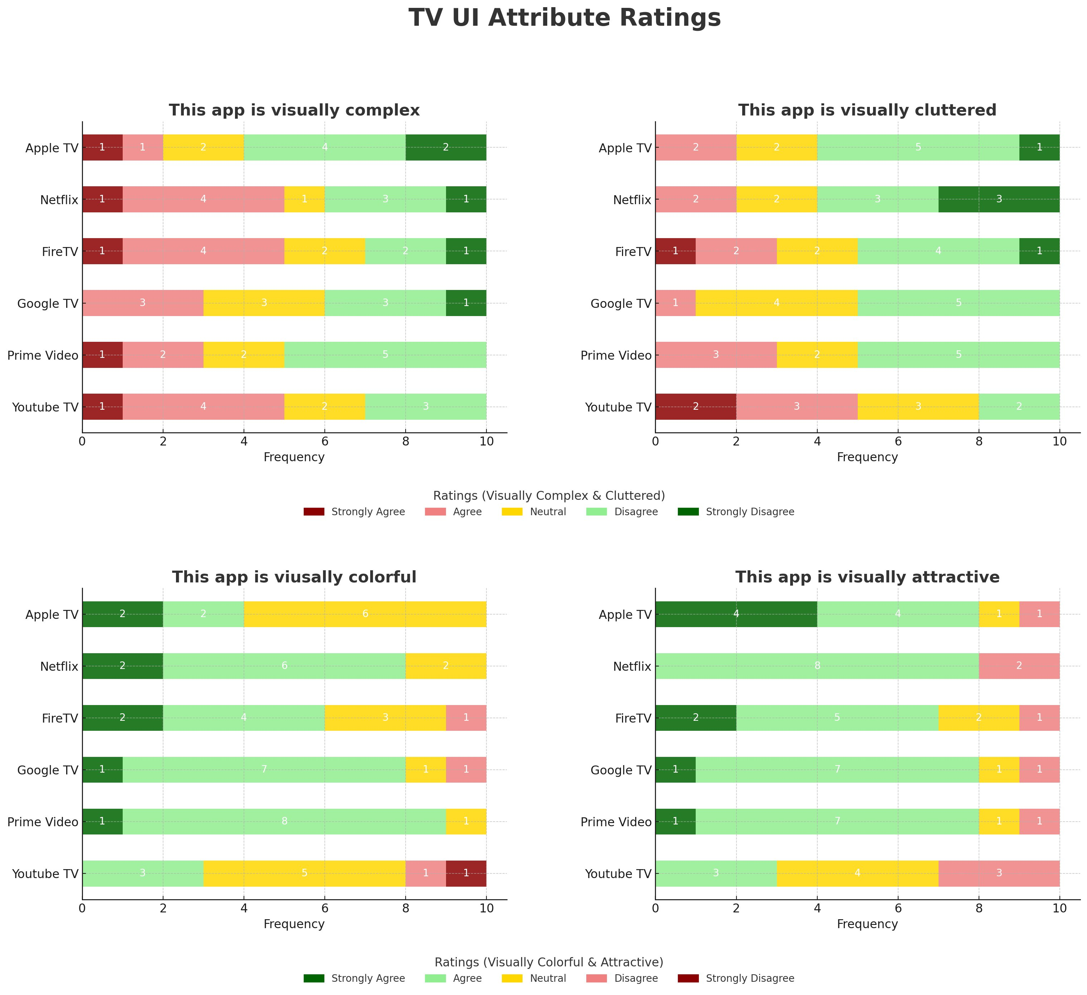

Several factors were found to influence customer perceptions of UI aesthetics. Beyond the prioritized UI attributes mentioned earlier, customers were asked to describe what attractive aesthetics mean to them in the context of TV streaming experiences. Commonly cited attributes included video preview and content image quality, font size and spacing, spacing between content tiles, background and foreground contrast, and the ease of content discovery and scrolling. Overall, these attributes were reported to impact visual attractiveness and were grouped into two major themes:
1) perceived visual density, 2) mental demands for content search/discovery.

Perceived visual density, or "clutter," is a key attribute influencing customer perceptions of UI attractiveness. As illustrated in the images below, each TV UI varies in their magnitude of visual density. Factors such as the spacing between content tiles, proximity of header labels, the number of content tiles displayed in a row, and the orientation of tiles (portrait vs. landscape) all contribute to perceived visual density. For instance, three customers observed that a portrait orientation of tiles on Netflix allowed more content to appear in a single row, reducing the need to scroll with the remote. Additionally, the platforms differed in how they presented content previews: some, like Prime Video and Netflix, dedicated the top half of the UI to text summaries and video previews, while others, such as Apple TV and YouTube TV, only displayed previews after content selection.
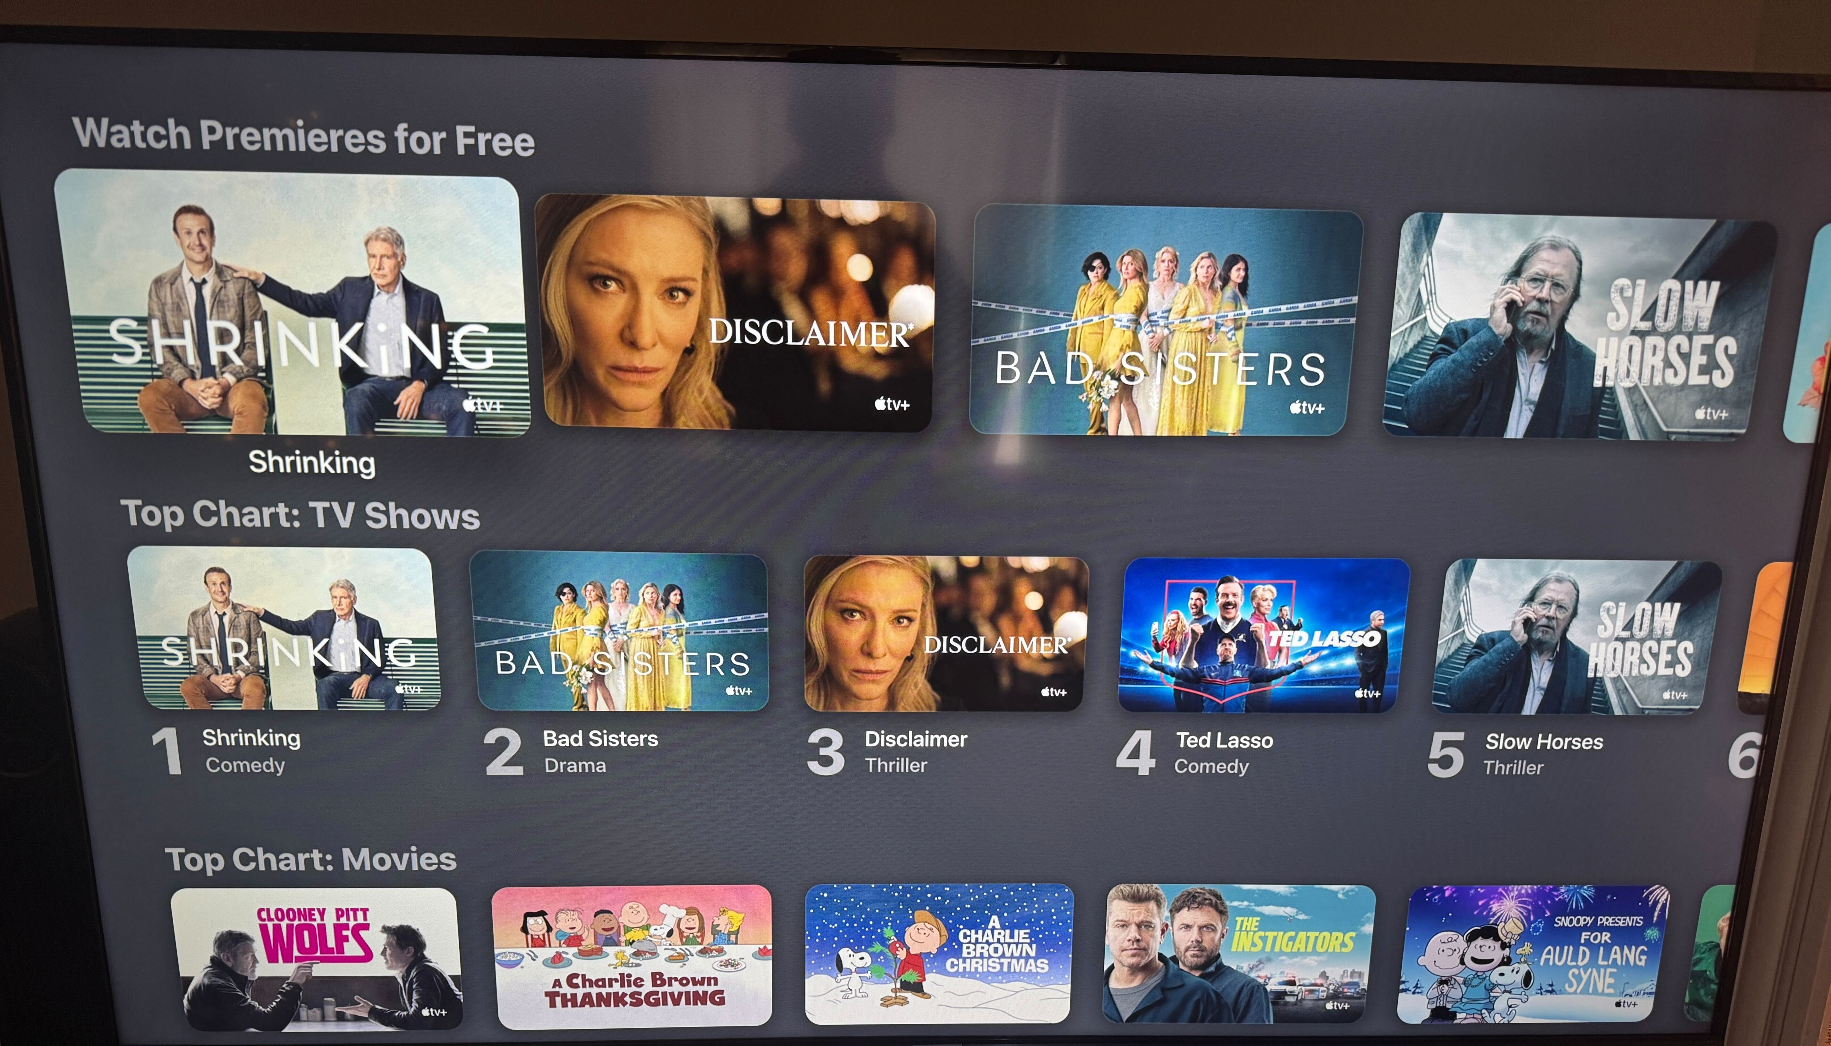
Apple TV has more spacing between content, fewer items per row, displays tiles in landscape orientation and has no dynamic previews
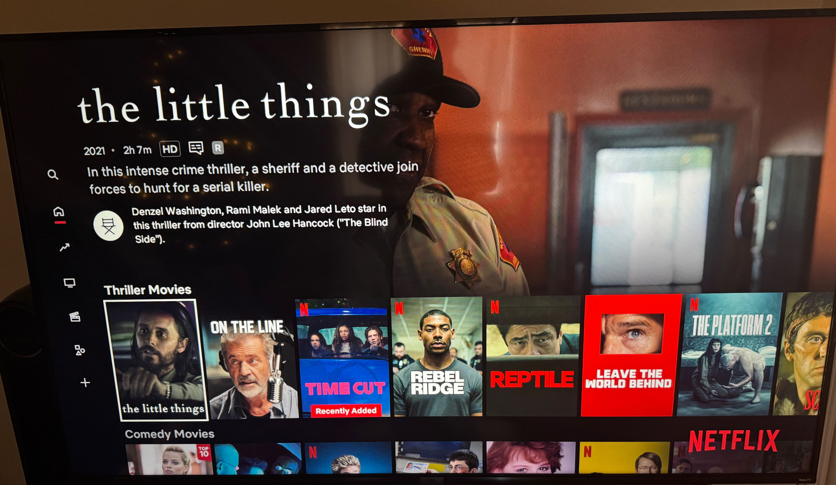
Netflix has less spacing between content, shows the most content per row, displays tiles in portrait orientation, and shows previews for content when highlighted

Perceived visual complexity is defined by customers as the cognitive demand needed to navigate the interface. The higher the perceived complexity of a UI, the more mental processing is required to locate content. Several factors contribute to perceptions of complexity:

First, the placement of the navigation menu significantly impacted customers’ perceptions of UI attractiveness. Different platforms use varied approaches to menu placement: 1) a persistent, left-aligned menu (Prime Video, Netflix), 2) a transient, left-aligned menu (Apple TV), and 3) a persistent, top-aligned menu (Fire TV, Google TV, YouTube TV). Each approach has trade-offs in terms of visual aesthetics. For instance, two customers noted that the persistent, left-aligned menu on Netflix is always accessible but occupies about 1/8 of the screen width. Transient menus, while less visually intrusive, lack signifiers to remind customers how to access them, and top-aligned menus can be challenging to reach quickly, especially when customers have scrolled down the page.

A second factor influencing perceived complexity is the visual consistency of UI elements. Attributes such as content tile size, video behavior, and subtext inclusion all affect how cohesive the interface feels. Customers noted that when UI elements are inconsistent, it becomes harder to predict how the platform will function, increasing the cognitive load required to find content. As shown below, Fire TV blends video content and apps into rows with the same tile shapes, causing confusion. In contrast, Google TV effectively differentiates these content types by using distinct container shapes, making navigation more intuitive.

A third factor that influenced perceived complexity were the focus state and motion scrolling cues. Customers noted differences in the fluidity, or "smoothness," of scrolling across various UIs. While some interfaces, like Apple TV, felt responsive and seamless, others were described as laggy (e.g., YouTube TV). Approaches to highlighting selected content also varied: some platforms used prominent cues, such as enlarging the selected tile and increasing its brightness, while others provided minimal visual indicators to denote the selected content.

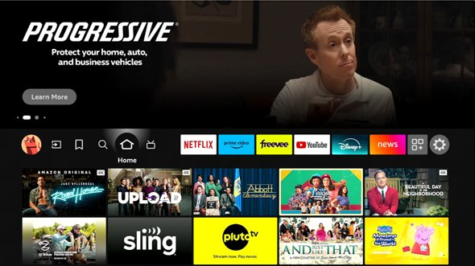
FireTV mixes content and apps leading to confusion
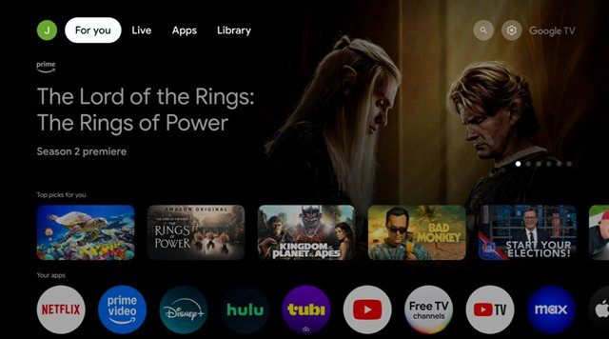
Google TV effectively differentiates video content vs apps

Fire TV and Prime Video can make several improvements to enhance UI attractiveness.
Overall, customers rated Fire TV in the middle tier among the six UIs for visual attractiveness. Key feedback highlighted the high density of content tiles, the overwhelming variety of content types on the screen (videos, apps, settings, ads), and a sense of complexity due to the difficulty in distinguishing content that can be played immediately from content requiring entry into another app. We believe that improving content organization—such as separating apps from video content—and adding more spacing between content tiles could lead to incremental improvements in customer perceptions of the UI’s aesthetic appeal.

“[FireTV] has so many things going on at once in this home screen. There’s apps, a bunch of shows that aren’t really organized, and even settings. It’s not clear how this is set up."

Prime Video received high ratings from customers for visual attractiveness mainly due to its balanced content density, high quality video previews, and organized layout. However, there were a few points of negative feedback. Common issues included perceived inconsistencies in video tile sizes and truncated text in video descriptions, which required users to click into content to read the full summary. Additionally, two customers noted that not all videos autoplayed when hovering over the content tile, making it difficult to predict how the UI would behave.
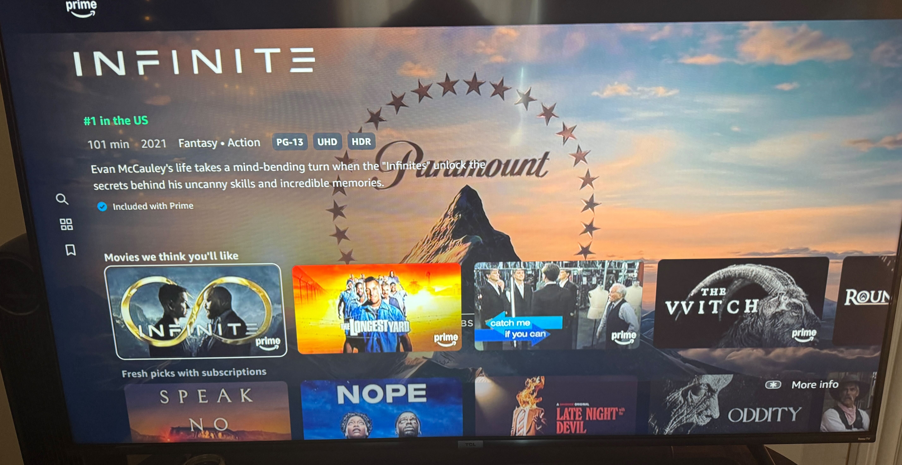
Prime Video

Brain scanning and eye tracking data offers additional support for the subjective customer sentiment data

Brain data (WIP)
To measure mental activities during judgments of the different UIs we used a brain scanning tool that uses near-infrared light (fNIRS) to monitor Dorsolateral Prefrontal Cortex (DLPFC), which is related to mental effort and could be an indicator of visual clutter and complexity. A significant difference was observed at channel 43, the left DLPFC which Apple TV showed a lower level of activity (less mental effort) whereas YouTube TV showed a higher level of activity (higher mental effort). Fire TV showed a similar level of DLFPC activation to Apple TV whereas Prime Video resembled YouTube TV, suggesting that Fire TV UI required less mental effort to consume when comparing to Prime Video.
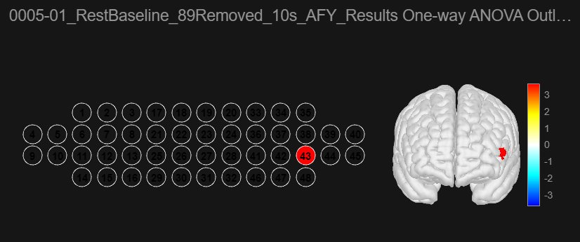
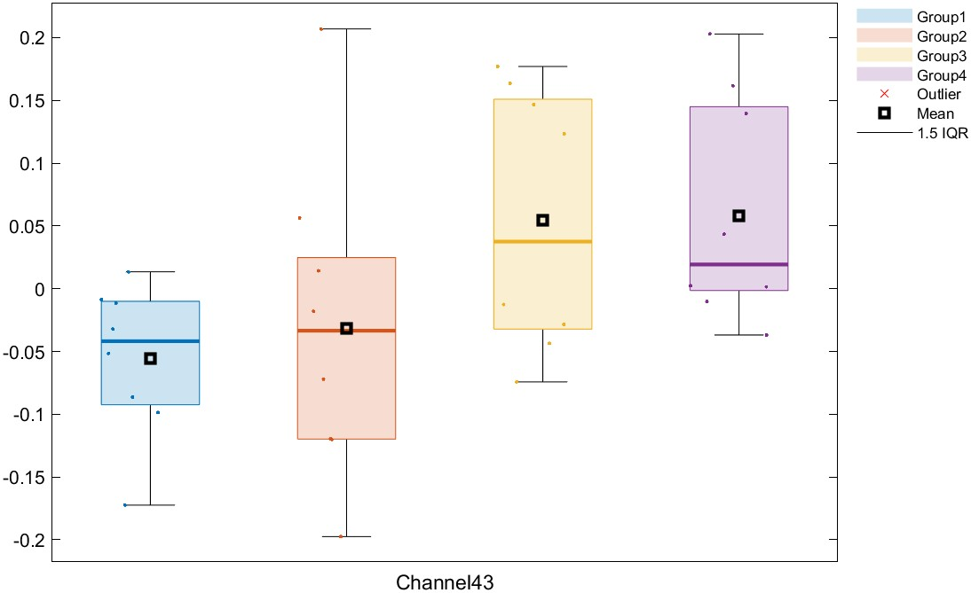
Figure: Group 1 - Apple TV; Group 2: -FireTV; Group 3 - Prime Video; Group 4 - YouTube TV

Eye-tracking data:
A heatmap for each TV experience was generated throughout the duration when the participants were interacting with the UI to understand their strategies on viewing the content.
- Apple TV & Prime Video: Most of the attention was at the left and at the center, implied that people might easily overlook content at the right. For Prime Video the use of big banner further attracted people attention as the show title was close to the center. As Prime Video has the UI at the top people attention were redirect a bit to the top menu bar.
- Google TV: Used a lot of the big banner that span over half the screen and occasionally description texts below the tiles so the gaze pattern is more scattered, but still most of the focus was at the left. And content at the right side might be ignored
- FireTV: More horizontal scrolling, people seems to look at a broader area compared to Apple TV and Prime Video, could result from it occasionally mixed in the larger tiles which might expand people’s field of view a bit.
- Netflix: There are move vertical scans, although most attention was still at the left. This could result from Netflix UI is more dense and tiles are in portrait, could also imply more tiles fall under the field of view that people scanned them more (red marks were separated)
- YouTube TV: Has the most scattered gazes as each content usually comes with descriptions, has horizontal scroll menus, and also tiles in various size and shape. This might invite people to explore more and beware of what’s on the screen as well as getting more info about specific contents, but can also be distracting and increase mental effort to scan the whole screen.
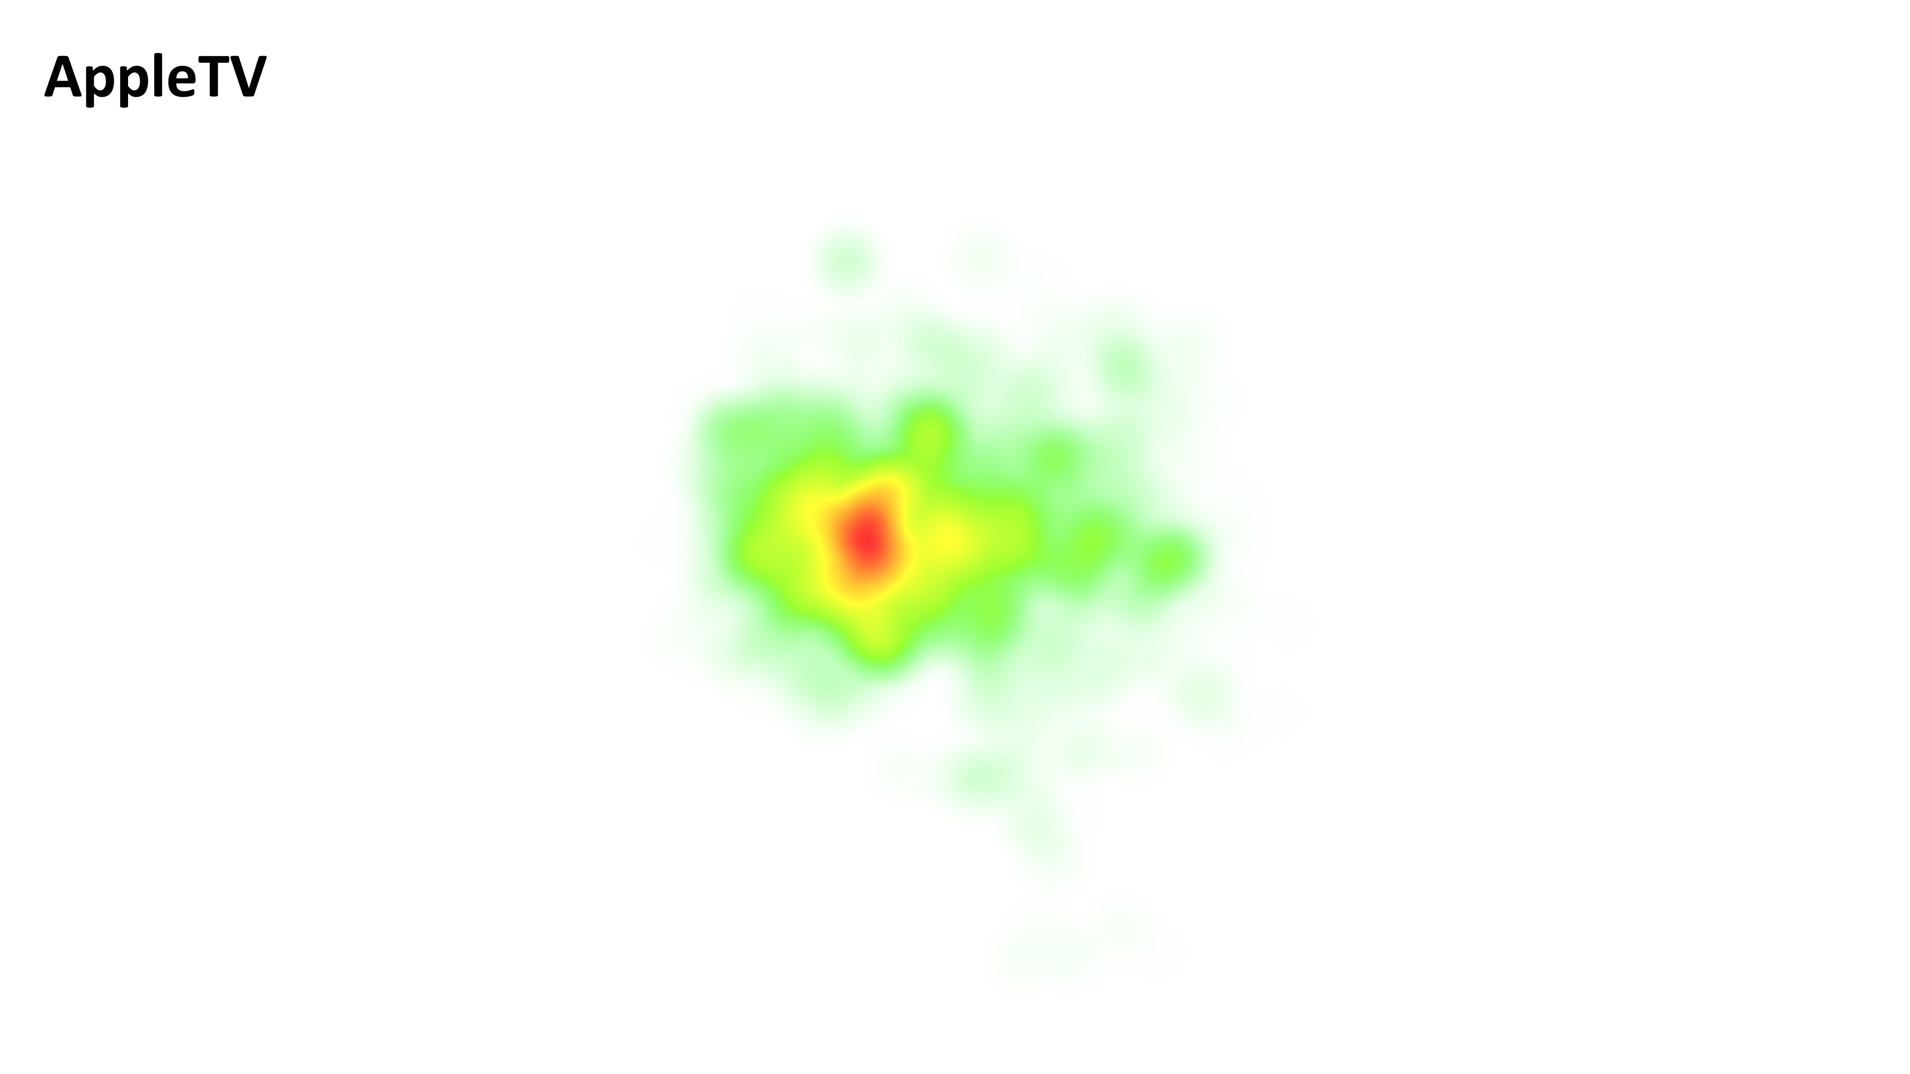
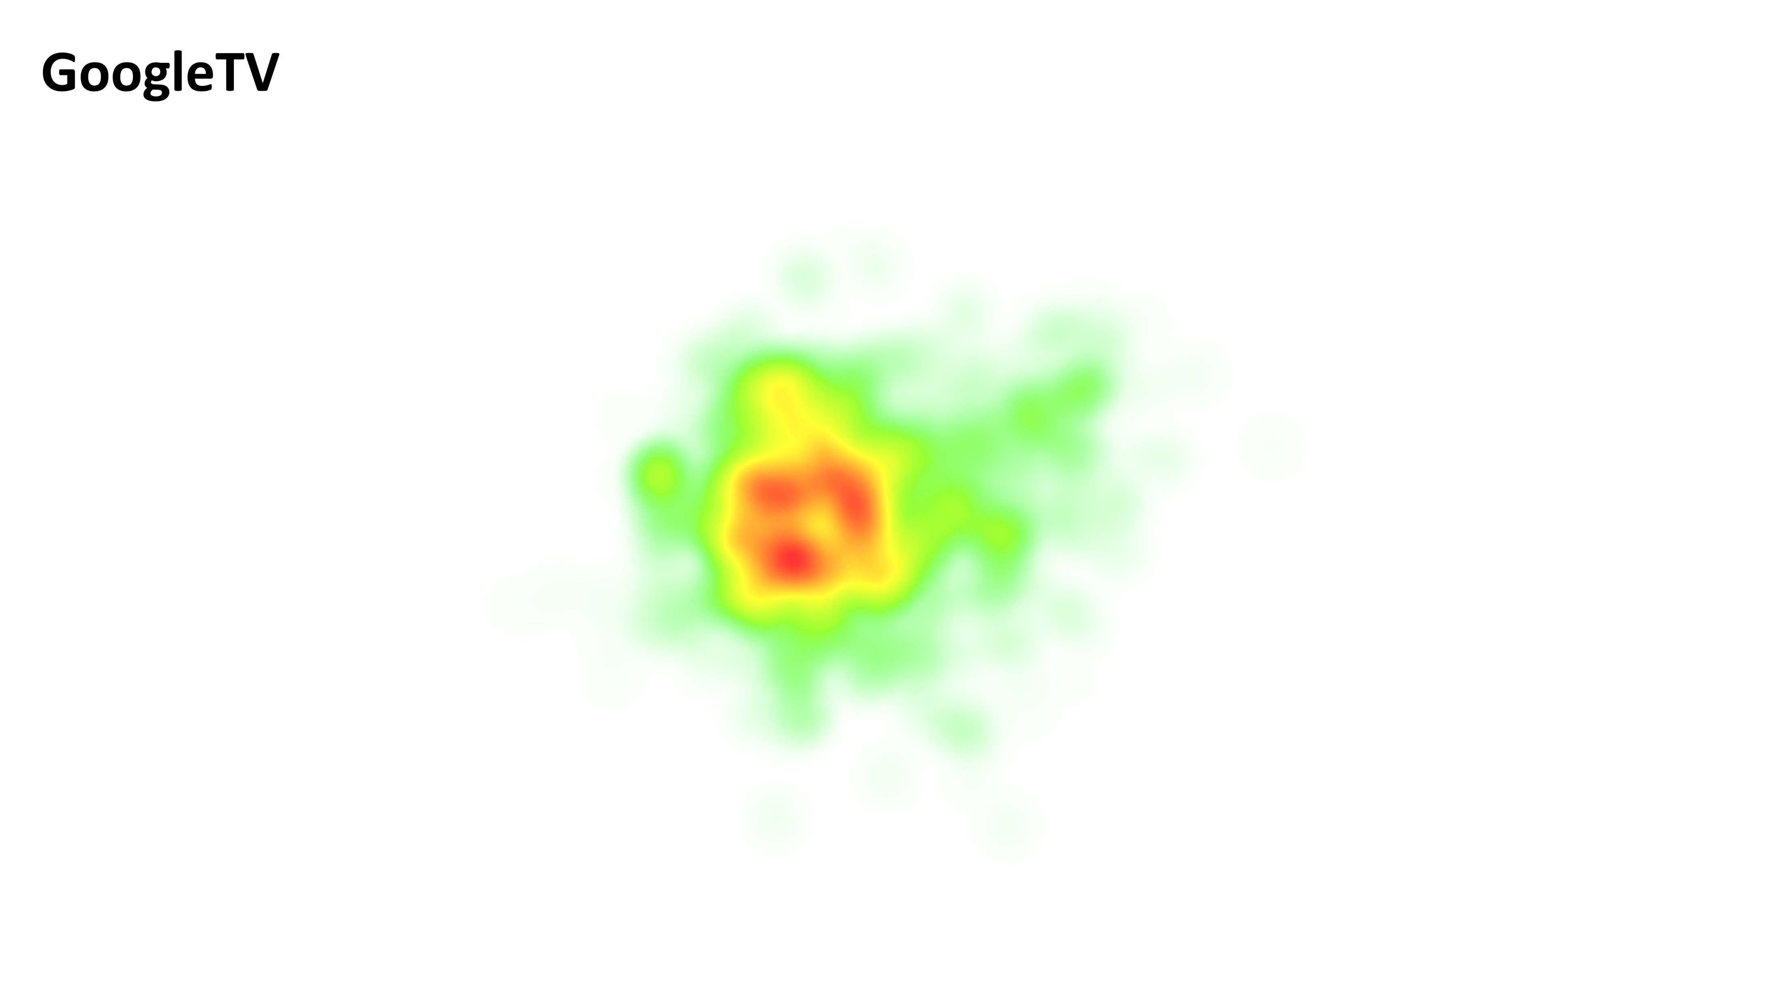

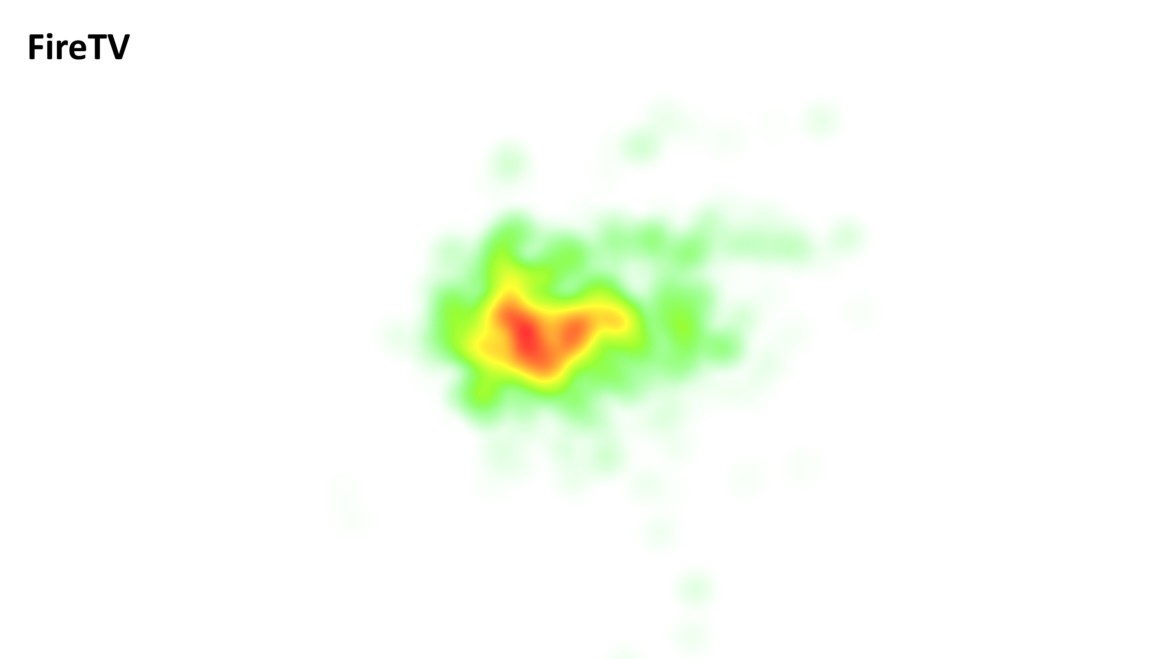
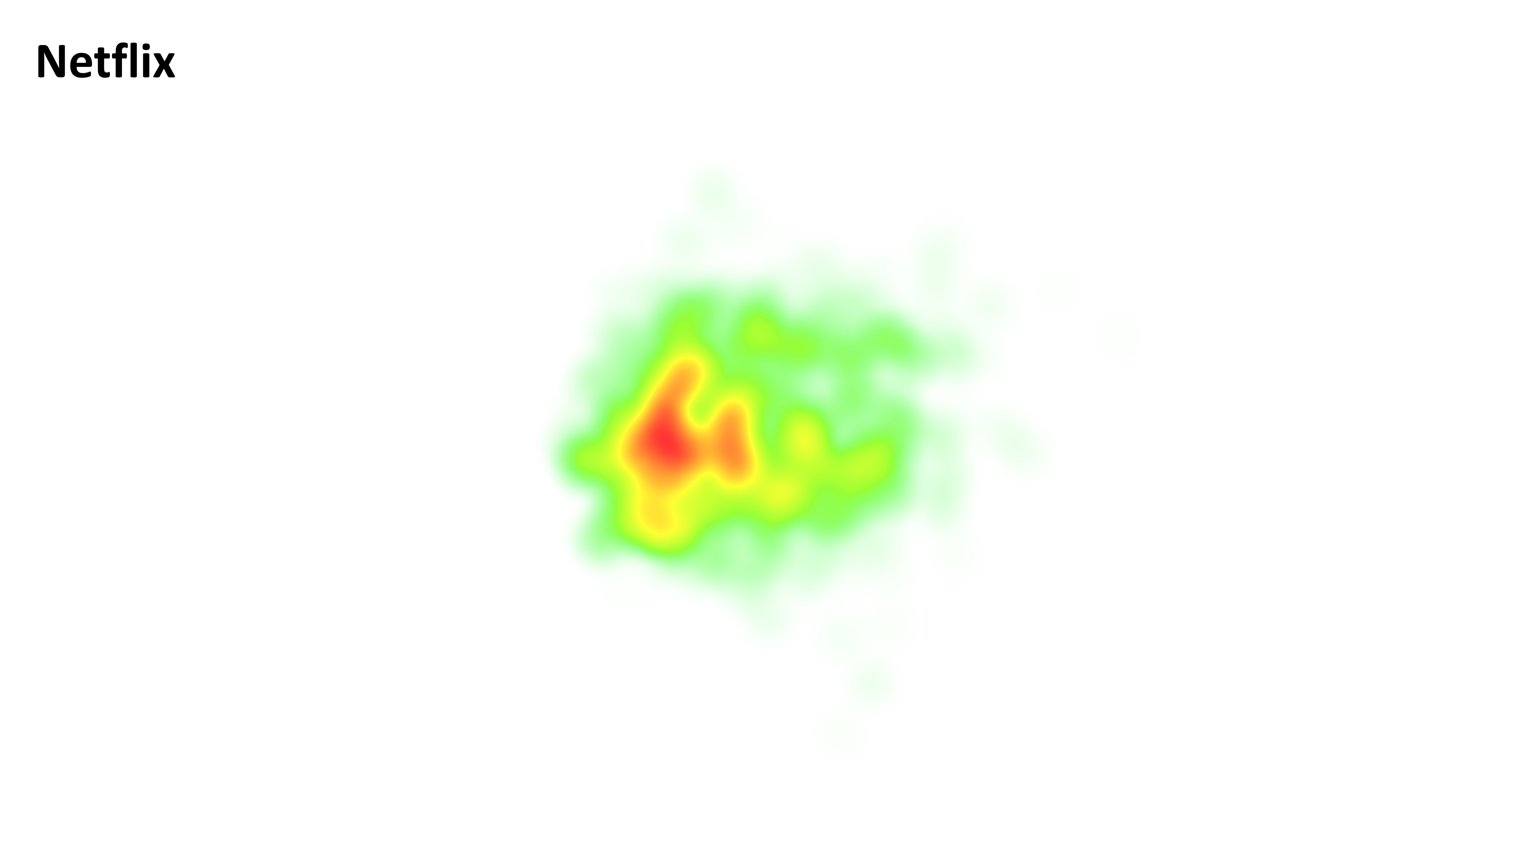
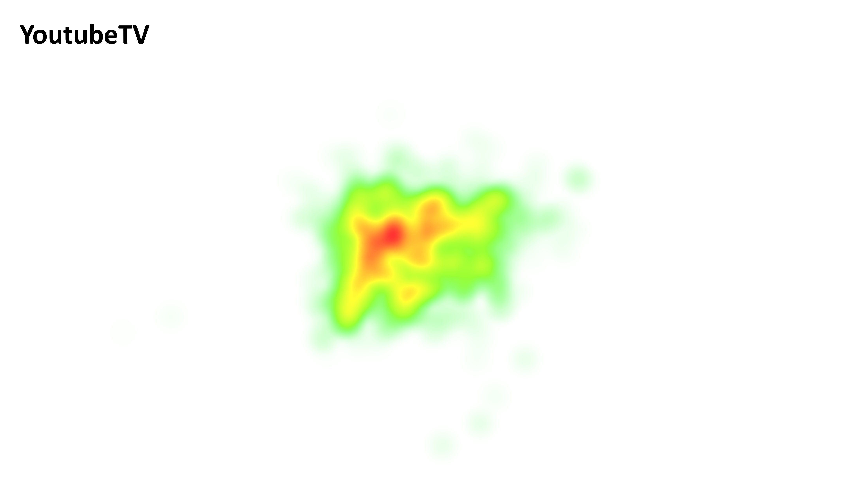
_____________________________________________________________________________________________________________________________________

Appendix A: Overall Attractiveness Ratings


Appendix B: Method
This study had eleven representative customers scroll for 30 seconds through the home UIs of the following TV-based experiences: Fire TV Omni Edition, Google TV, Apple TV, YouTube TV, Prime Video, & Netflix. (note: accounts for these experiences were not the customers’ unique accounts, but DDG owned accounts with no personalization). Customers were fit with the eye tracker and the fNIRS brain scanning device and sat at a desk 5 feet from a 65 inch TV. After scrolling each UI, customers were asked to rate a series of UI attributes (visual attractiveness, colorfulness, visual complexity, and visual density) using a scale of strongly agree to strongly disagree. These attributes were selected based on prior research that identified core attributes when evaluating visual aesthetics for digital UIs [(Lavie & Tractinsky (2004) and Schmidt & Wolff (2018)].

Appendix C: Study Script

Introduction (5 min)
- Thank you so much for your time today. My name is Brandon, I’ll be moderating this session.
- We have about the next hour together. I’ll be asking you a lot of questions and we’ll be doing a few activities, but at no point is this a test of you or your ability or understanding.
- We are recording these sessions - that’s really just for my notes and to make sure that we’re accurately representing what you say. We don’t share these videos anywhere outside of our immediate product team.
Testing (30 min)
- Today we will be showing a variety of TV experiences such as FireTV, Apple TV, Netflix and many more. We will be getting your feedback on the visual design of these different experiences
- Specifically, I will show you the home screen of one TV experience at a time on this TV in front of us.
- You'll scroll each UI for 30 seconds. I want you to imagine that this is your first time loading up this app in a while and you want to find something interesting to watch. Does this make sense?
- After seeing each screen, I will ask you a variety of questions regarding the visual qualities of each home screen.
- To give a rating for each of these qualities, you will use this iPad here in front of you. Ranging from strongly disagree to strongly agree.
- Does this make sense?
- Baseline Start!
- Start Tasks
- Baseline End!
Post Task Discussion (30 min)
- Stack Ranking exercise
- Why was [x] most attractive?
- Why was [x] least attractive?
- In your own words, what does attractive design mean to you?
  - Please describe and call out specific examples on the device(s) as examples.
- Was there anything in any of these UIs that was particularly surprising / interesting / noticeable?
- What are your thoughts on ads or promoted content?
  - How does this impact the visual design?

